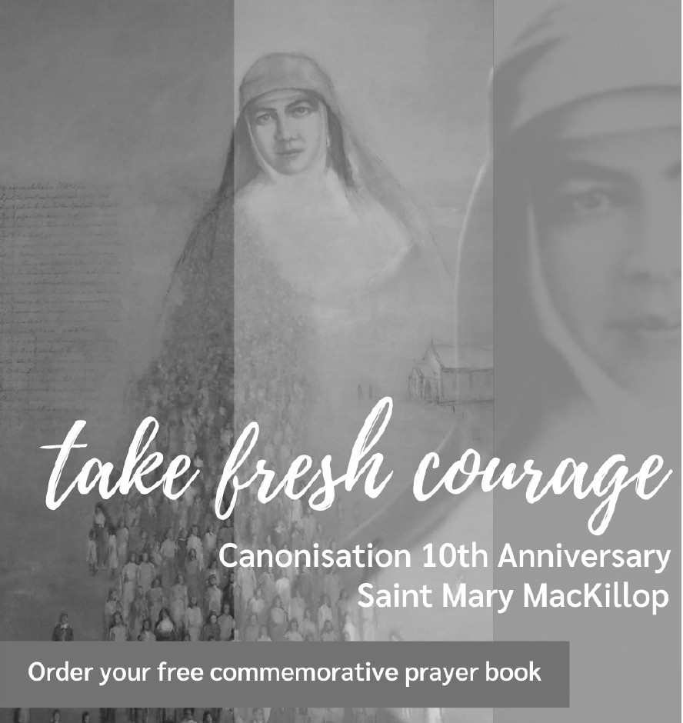
To celebrate the 10th Anniversary of the canonisation of Saint Mary MacKillop

We invite you to order your free copy of
Encountering St Mary MacKillop in Prayer

The Sisters of Saint Joseph have created a commemorative prayer booklet to inspire us all to "take fresh courage..." as Mary did so often.
These prayers share details of her personal journey, highlighting Mary's values and spirit, and offering prayers and blessings for our modern world.

To order your exclusive copy please go to: www.marymackilloptoday.org.au/prayer-book or call us on Ph: 02 8912 2777


